# Practical-3

Using of TV database and shows collection.

1.

Output:

2.

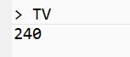

Output:

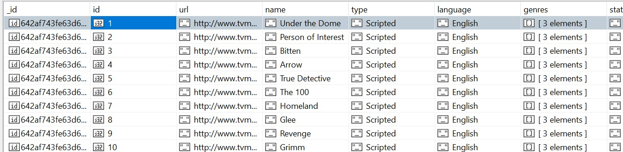

3.

Output:

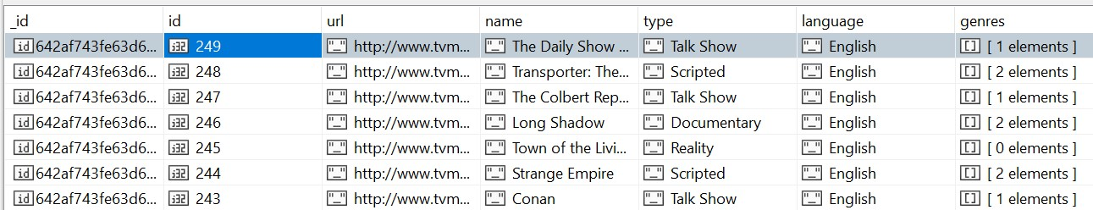

4.

Output:

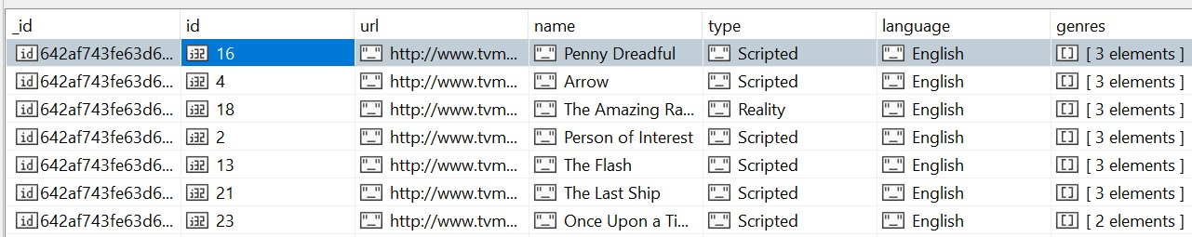

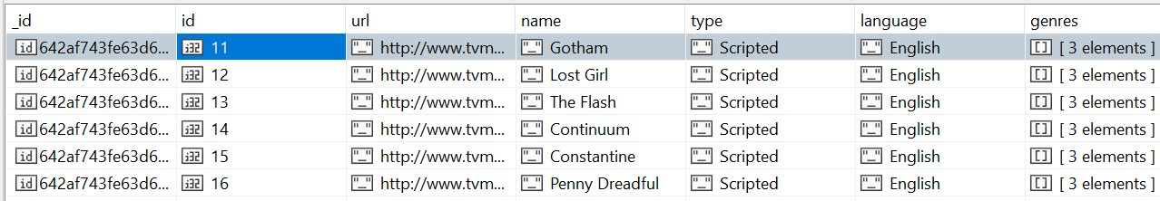5.

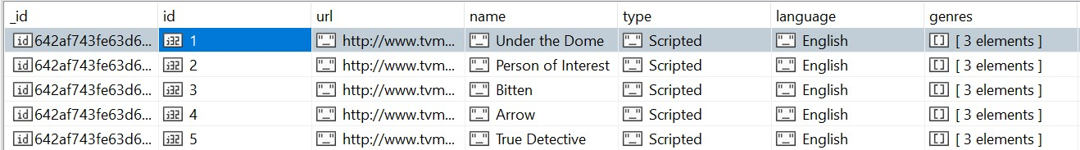

6.

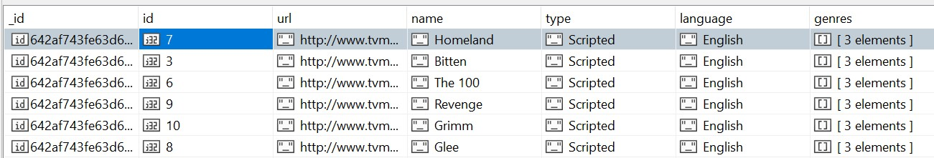

7. We can use multiple function in one lien and execute it like:



Output: